
ISTANBUL TECHNICAL
0
1
UNIVERSITY

COMPUTER ENGINEERING
COMPUTER ORGANIZATION

PROJECT # 4
SIMPLE COMPUTER WITH
MICROPROGRAMMED CONTROL UNIT
REPORT

STUDENT NO NAME SURNAME
040100113 MUSTAFA UÇAR
040100117 TUĞRUL YATAĞAN
040100124 EMRE GÖKREM
040100054 HÜSEYİN ERDOĞAN

DUE DATE: 16.05.2013

INSTRUCTION SET FOR SIMPLE COMPUTER

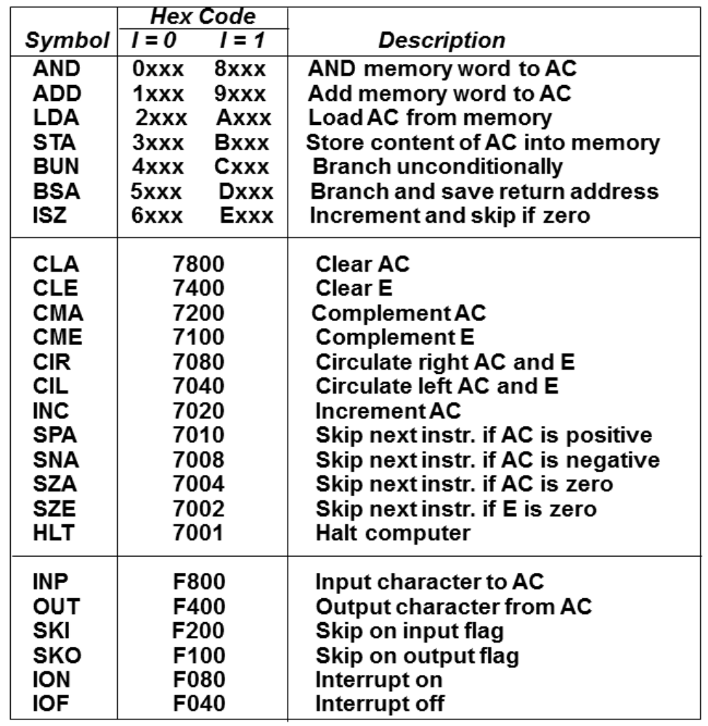

There are only two external input for simple computer, these are FGI and FGO input-output flags for the rest simple computer needs machine codes on its RAM for work. Computer will halt when HLT instruction comes.

MICROINSTRUCTION FORMAT
4 | 4 | 4 | 4 | 2 | 8
F1 | F2 | F3 | CD | BR | AD

F1, F2, F3: Microoperation fields (4 Bit)
CD: Condition for branching (4 Bit)
BR: Branch field (2 Bit)
AD: Address field (8 Bit)

MICROINSTRUCTION SET FOR CONTROL UNIT

F |  | F1 | F2 | F3
0 | 0000 | NOP | NOP | NOP
1 | 0001 | AC ← AC' | AR ← IR(0-11) | AR ← 0
2 | 0010 | AC ← AC - DR | AR ← M[AR] | AR ← AR + 1
3 | 0011 | AC ← AC ˄ DR | AR ← PC | DR ← DR + 1
4 | 0100 | AC ← AC + DR | DR ← M[AR] | E ← 0
5 | 0101 | AC ← AC v DR | IR ← M[AR] | E ← C_{out}
6 | 0110 | AC ← DR | M[AR] ← AC | E ← E'
7 | 0111 | AC ← cir AC | M[AR] ← DR | FGI ← 0
8 | 1000 | AC ← cil AC | M[AR] ← PC | FGO ← 0
9 | 1001 | AC(0-7) ← INPR | M[AR] ← TR | I ← IR(15)
10 | 1010 | AC ← 0 | OUTR ← AC(0-7) | PC ← 0
11 | 1011 | AC ← AC + 1 | PC ← AR | PC ← PC + 1
12 | 1100 | R ← 0 | TR ← PC | S ← 0
13 | 1101 | R ← 1 | IEN ← 0
14 | 1110 |  | IEN ← 1
15 | 1111

F1 generally keeps ALU operations, F2 generally keeps BUS operations and F3 keeps register control operations. Some register control operations distributed over F1 and F2 according to control different registers simultaneously.

CONDITION DIAGRAM FOR NEXT ADDRESS LOGIC

CD |  | CONDITION |  | COMMENT
0 | 0000 |  | U |  | Unconditionaly branch
1 | 0001 |  | I |  | Indirect adress bit
2 | 0010 |  | N |  | Interrupt flag
3 | 0011 |  | DR |  | Value of DR (0 if DR is empty otherwise 1)
4 | 0100 |  | AC |  | Value of AC (0 if AC is empty otherwise 1)
5 | 0101 |  | AC(0) |  | First bit of AC
6 | 0110 |  | AC(15) |  | Last bit of AC
7 | 0111 |  | E |  | E flag
8 | 1000 |  | FGI |  | FGI flag
9 | 1001 |  | FGO |  | FGO flag

BR |  | BRANCH
0 | 00 | JUMP
1 | 01 | CALL
2 | 10 | RETURN
3 | 11 | MAP
MAPPING

TYPE OF INSTRUCTION | MAPPING | ADRESS RANGE
Memory Reference | 010XXX00 | 64-92
Register Reference | 001XXXX0 | 32-54
Input-Output | 000XXXX0 | 12-24

Memory reference instruction
Opcode of machine code is used for mapping.
Example memory reference instruction: B210
B → 1011 opcode is 011 so
XXX is 011

Register reference and Input-Output instruction
Only one of the bit from 12 bit address field of machine code is 1. Position of this bit is used for mapping.
Example instruction: 7080
Address field is 080 → 0000 1000 0000
1 is 7th bit of address field 7 → 0111 so
XXXX is 0111

